 | 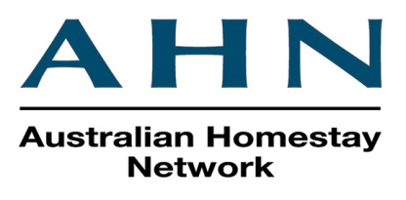  STUDENT GUIDE TO THE HOUSE RULES  Including Under 18 and Study Tour Guidelines  Welcome to Australia! We hope you enjoy your stay. Below are guidelines, which will help to create a happy home for everyone.
Write these details down and keep them on you in case of an  emergency | Telephone numbers  AHN 24 hour = 1300 MYSTAY (1300 697829)  Police/Fire/Ambulance Emergency: 000  Host Name: _____________________________________________________  Address: _____________________________________________________  _________________________________________________________________  Home Phone: _____________________________________________________  Mobile: _____________________________________________________  Email: _____________________________________________________
 | Contacting you in Australia:  - Between you and your family: Please use your mobile phone or purchase a pre-paid phone card.  - Between you and AHN/your host: You need to advise your email address and Australian mobile number as soon as possible.
 | Payments for your stay:  - Homestay invoices are sent to you via email and can be viewed in the AHN system.  - If you have forgotten your login details, please reset your password via this link: https://auth.homestaynetwork.org/forgot_password  - Payment Reference - Please use your GUEST ID as your payment reference so that AHN can match your payment to your invoice.  - Payments must be made in full by the due date listed on your invoice.
 | House Key  Your host will provide you with your own house key when you arrive. If you lose the key you may be charged for the cost of a replacement key. The key is to be returned to your host before you move out. When leaving the house daily, please ensure that you:  - Turn off lights, fans, air conditioning, heating, laptops, etc. at the wall or power board switch in your room and close any windows.  - Lock the outside door as you leave.  - Other: _____________________________________________________  - Other: _____________________________________________________
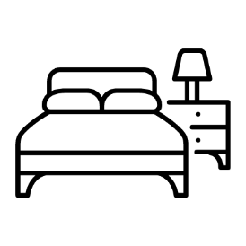 | Your Room  - In Australia, we sleep in a bed, between the sheets, with blankets on top.  - Bed sheets, pillow cases and towels are to be changed at least once every two weeks. Your host will show you where to find these if they would like you to change them yourself.  We ask you to please;  - Keep your room clean and tidy.  - Do not cook, eat, or keep food in your room.  - Do not leave any wet clothing or towels in your room.  - Do not stick anything to the walls. If you wish to hang anything, see your host.  - Ask your host if you need extra blankets if you are cold or a fan if you are hot.
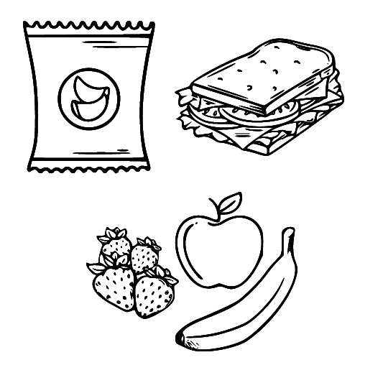  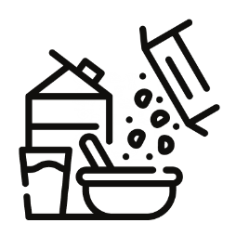     | Meals  Students have different meal options with their homestay, although Under 18s will generally be required to book the Traditional or Complete Homestay package.  Your host or AHN can show you which meal plan you have chosen (check your invoice, AHN Placement Report or log in to your AHN account).  Traditional Homestay -– Your host will provide you with breakfast and dinner Monday-Friday + breakfast, lunch and dinner Saturday-Sunday. You must buy your own food to make your lunch Monday-Friday.  Complete Homestay -– Your host will provide you with breakfast, lunch and dinner 7 days a week.  Dinner Only – Your host will provide you with dinner 7 days a week. You must buy your own food to make your breakfast and lunch.  No Meals – You have chosen to purchase and prepare all of your meals. Your host will show you where you can store your food.  If you would like your host to provide more/less meals than what is included with your current package, please discuss it with your host and contact your local AHN office to change your meal plan.  NOTE: Eating 2-3 serves of breakfast or taking extra dinner helpings for your lunch the next day is not OK unless your hosts invites you to. You must purchase a package with lunch included if you want your host to provide it.  Breakfast and lunch are self-service meals, however, your host will prepare dinner for you (if it is included in your package).  The information below should be used as a guide if your package includes meals.  Breakfast  - This will typically be cereal, toast, fruit, juice, tea or coffee. The food will generally be provided and you will prepare it yourself.  - Australians normally have a cold breakfast.  Lunch  - This could include sandwiches, salads, fruit or muesli bars but may also be noodles or a hot meal.  - ‘Leftovers’ is food cooked the night before and put into containers in the fridge that you can then heat up again for lunch.  Dinner  - Can be hot or cold.  - Discuss with your host what food you don’t like so this can be considered when they make their family meal.  - Dinner is normally served early in the evening in Australia. Ask your host what time they usually eat.  - It is polite to let your hosts know by 4:00pm if you will not be home for dinner or will be late so that food is not wasted.  - Dinner is a time to be with the family and talk. Please take the time to sit with them and enjoy the meal together. It is considered rude to use your phone at the dinner table.  Snacks  - Hosts must have 1-2 pieces of fruit available for you each day.  - Other snack foods (e.g. chocolate, muesli bars, soft drinks, etc.) are not included in your homestay fees. You will need to purchase these items yourself.  Your host may offer you additional food, however, please do not help yourself without asking or being invited.  Kitchen  Please make sure that you leave the kitchen clean and tidy after you use it. Speak with your host if you need to prepare food before 6:00am or after 8:00pm.  Under 18s are not allowed to cook on their own and must ask permission before using the kitchen. Hosts may not allow younger students to cook or use certain appliances in the kitchen without supervision.
 | Health Issues  - Tell your host if you are feeling unwell. They’ll advise you where the nearest medical centre is and assist you.  - You may have to pay to see the doctor, however your OSHC may cover some medical costs. Dental and optical are not covered under your health insurance. You will receive your health care card on orientation day at your school.  - 13SICK is the number for medical assistance after 6:00pm at night and before 6:00am in the morning.  - Visit ahnhomestay.co/medical-help-aus for more info.  - If you are having a challenging time, it is OK to seek help and support. You can reach out to the below organisations for assistance.  All Ages  - Beyond Blue 1300 224 636  - Lifeline Australia 13 11 14  Lifeline also offers a free interpreting service. To access this service:  1) Call TIS National on 131 450 and ask to talk to Lifeline on 13 11 14 in the language required.  2) TIS National will call 13 11 14 on your behalf.  25 and Under  - Headspace 1800 650 890  - Kids Helpline 1800 55 1800
 | Personal Hygiene  - Australia can have very warm weather.  - Showering every day and putting on deodorant before dressing will help you feel fresh and clean.
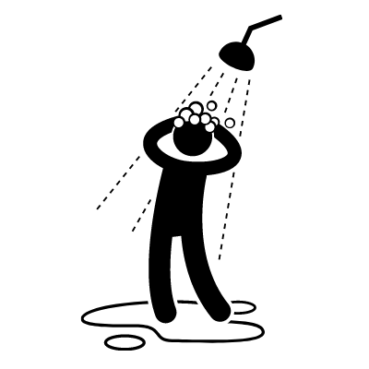 | Bathroom  - Please only bathe in the bath or shower cubicle so water does not splash onto the bathroom floor.  - When using the bathroom, close the door. There may be a privacy lock on the door, please use it.  - There is usually a bath mat on the floor. Stand on that when you get out of the shower so you do not slip over.  - Hang your towel up to dry after you use it. Check with your host family where you should hang your wet towel.  - Have a toiletry bag with your own shampoo, soap, tissues, etc.  - Leave any wet items in the bathroom or hang out to dry – please do not leave them in your room.  - If you make a mess, please clean it up.  - Please complete all shower activities by 10:00pm. If you need to shower later for some reason, please chat to your host.
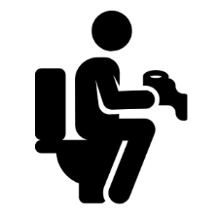 | Toilet  - Never squat or stand on the toilet seat.  - Never flush anything down the toilet except for toilet paper.  - Don’t use too much toilet paper as it may block or cause the toilet to overflow.  - Always wash your hands with soap after using the toilet.  - Please wipe down any spills on the toilet after you have finished.  - Please use the provided toilet brush to remove any marks left in the toilet bowl after you have finished.  Women/Girls  - All sanitary items such as tampons and pads should never be flushed down the toilet.  - At home, there will be a bin in the toilet or bathroom area or you may need to ask your host mother where to dispose of sanitary items.  - If you are still unsure, wrap the sanitary item in toilet paper and put in a plastic bag and then put it in the garbage bin outside.  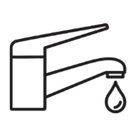  Water Usage – Water Restrictions  - Please help us save water by keeping shower times to 10 minutes or less and turning off the water whilst you brush your teeth.  - Please do not waste water. Water is expensive in Australia. While water  restrictions aren’t currently in place, conserving water is encouraged.
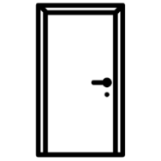 | Privacy  When you are sharing a home, it is important to respect each other’s private time and space.  - When in your room, toilet and bathroom remember to keep the door closed and if there is a lock please use it.  - Knock before you enter a room, especially any private use areas (bedrooms and bathrooms).
 | Laundry  Ask your host family about washing your clothes. Your host family may want you to:  - Do your own washing – your host will instruct you on how the machine operates and how much detergent to use. Full loads only please, 1-2 times per week.  - Once the washing is done, hang it on the clothesline to dry. Do not keep wet clothes in your bedroom.  - Some host may ask you to put your laundry items in a basket provided and your host will wash them for you.  - Ask your host if you would prefer to hang your underwear to dry in a private place.  - Your host will advise you what day you need to change the sheets on your bed and when to change your towels.
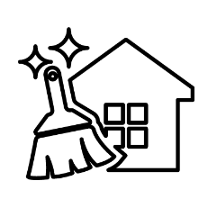 | Cleaning  In Australia, cleaning is part of family life. You are staying in someone’s home – not a hotel. Your host family may ask you to help out.  - Help with tidying up after meals, including washing or drying dishes.  - Keep your own room clean and tidy and make your bed.  - Keep your bathroom clean and tidy – do not leave wet towels and clothes on the floor.  - If you make a mess anywhere in the home, please clean it up. If you are unsure what products to use, chat to your host and they will help.
 | Noise  - Your host won’t mind you playing music or chatting with your friends via mobile or internet but please try to do this before 10:30pm at night.  - If you need to call your family after this time due to time zone differences, please check if this is ok with your host first.  - Always try to keep the noise level at a point where it doesn’t upset other family members or their sleep regardless of the time.
 | Internet  - Ask your host how the internet works in their home.  - The internet is for study purposes. Please be mindful of internet usage when it comes to gaming and entertainment.
 | Lights, Fans, Cooling and Heating  - Please make sure you turn off all lights when you go to sleep (ask your host for a small wall light if needed).  - Not all homes will have air conditioning and/or heaters. If they are available, they should be used moderately and switched off when you are going out.  - If you have access to an air conditioner, only use it when it is necessary and keep it at 24 degrees to conserve energy.  - You can ask your host for a fan to cool down or extra blankets if you are cold.  - During colder seasons, wear clothing that will keep you warm as heating can be expensive and your hosts might not have the heating on all of the time.
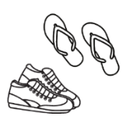 | Shoes inside the house  - Ask your host if shoes can be worn in the house.  - Please do not wear high-heel shoes on polished floorboards.  - Try to avoid wearing shoes on the carpet.
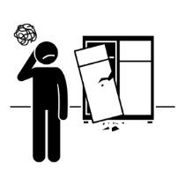 | Broken or damaged something in the house?  - Don’t worry, accidents can happen sometimes.  - Please let your host know if something has been broken or damaged.  - AHN students and hosts have some insurance coverage, however, you may be responsible for the cost of any minor repairs. Give AHN a call or email if you have any questions.
   | Smoking and Alcohol (not permitted for students under the age of 18 years old)  Do not smoke in the house –  - If you are over 18 and your host allows smoking at the house, you can only smoke outside and use the container provided for the butts.  - You cannot smoke inside the host’s home. Please ask if you have any problems or questions.  Be sensible with alcohol –  - If you are over 18 and your host allows alcohol at the house, be sure to drink responsibly and behave in a respectful manner.  - Remember that excessive drinking can have a negative impact on your studies and your personal life.
Friends
- If you wish to have friends visit you at your homestay, please ask your host for permission and confirm what time they should leave before you invite them over.
- You need to ask each time you would like to invite a guest to your homestay,
- It may not be permitted to have friends visit or sleep overnight.
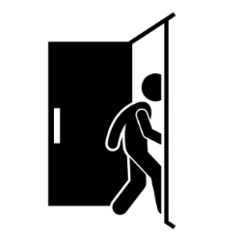 | Going Out  Over 18s  - It is polite to let your hosts know if you will be out late, just so they know you are safe.  - Be considerate of your host family if you get home late/very early in the morning. Try not to be too noisy.  - If you go out with friends at night or on weekends you must find your own way home either by public transport or taxi. Travel with friends, especially at night!  Under 18s  - If you are under 18, you must advise your host where you are going and when you will be home prior to going out at night. You need to be home by the curfew set by your welfare provider and/or host.  - Students under 18 years of age are not permitted to stay away from the homestay overnight without written permission from their welfare provider.  - If you are going to be home past your curfew, you must immediately contact your host to let them know when and how you will be getting home. Your education provide will be notified if there is a curfew breach.
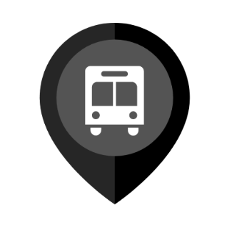 | Public Transport  - Download the local transport app on your phone and computer to work out the best and quickest route to travel.  - Ask your host and education provider about a transport card as this is cheaper than buying a paper ticket when using public transport. You must carry your valid student ID card to receive a concession or you may be fined a fee by the Transport department inspector.
 | Follow AHN Policies  - All homestay participants – Guests and Hosts – must abide by AHN policies throughout a placement.  - Public policies can be found at https://au.homestaynetwork.org/policies.
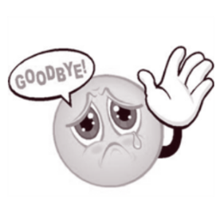 | Leaving Homestay  You are required to give AHN and your host family two weeks’ notice in writing. Send AHN a message through the system or email your local office if you wish to give notice.  You are not permitted to enter into a private arrangement with your host.

Other House Rules
- __________________________________________________________
__________________________________________________________
__________________________________________________________
- __________________________________________________________
__________________________________________________________
__________________________________________________________
- __________________________________________________________
__________________________________________________________
__________________________________________________________
- __________________________________________________________
__________________________________________________________
__________________________________________________________
- __________________________________________________________
__________________________________________________________
__________________________________________________________
- __________________________________________________________
__________________________________________________________
_________________________________________________________
- __________________________________________________________
__________________________________________________________
__________________________________________________________

